Thea Astley’s Fictional Worlds
Edited by Susan Sheridan and Paul Genoni
Cambridge Scholars Press, July 2006
1-84718-015-9, 220x150 (mm), 222pp, Cloth, UK:34.99pnds, US:$69.99

“This landmark contribution to Australian literary studies is the first collection of critical responses to the work of one of our most important novelists, Thea Astley. As well as essays from leading Australian and international critics, dating from 1967 to the present, it includes three essays by Astley herself, a major interview with her and the first Thea Astley Lecture, given by Kate Grenville in 2005.”
Professor Elizabeth Webby, Sydney University

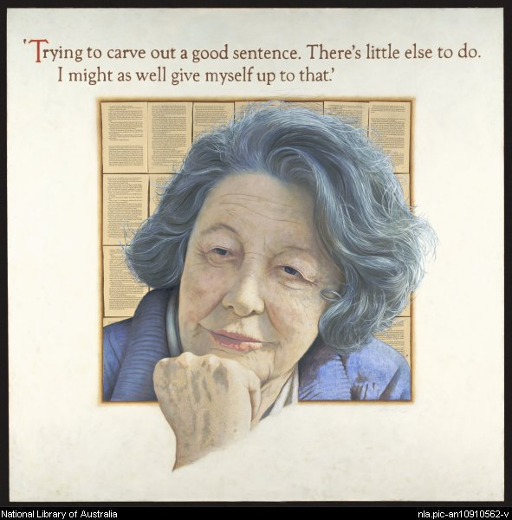

Susan Sheridan is Adjunct Professor of Women’s Studies at Flinders University and a Fellow of the Australian Academy of Humanities. She has published extensively in feminist studies and Australian cultural history, her books including Christina Stead (1988), Along the Faultlines: Sex, Race and Nation in Australian Women’s Writing, 1880s to 1930s (1995) and Who Was That Woman? The Australian Women’s Weekly in the Postwar Years (2002).

Paul Genoni is a Senior Lecturer with the Faculty of Media, Society and Culture at Curtin University of Technology. He has a PhD in Australian literature from the University of Western Australia and is the author of Subverting the Empire: Explorers and Exploration in Australian Fiction (2004).

Order from your library supplier or direct from www.CambidgeScholarsPress.com
Or write to CSP, 15 Angerton Gardens, Newcastle upon Tyne, NE5 2JA, UK.
Thea Astley’s Fictional Worlds
Edited by Susan Sheridan and Paul Genoni
Cambridge Scholars Press, July 2006

Table of Contents

Preface ix
Introduction xi
1 Thea Astley Why I Write 1
2 Thea Astley The Idiot Question 2
3 Thea Astley Being a Queenslander: A Form of Literary and
Geographical Conceit 7
4 Ray Willbanks Thea Astley: Interview 21
5 J. M. Couper The Novels of Thea Astley 36
6 Brian Matthews Life in the Eye of the Hurricane: The Novels of
Thea Astley 42
7 Kerryn Goldsworthy Thea Astley’s Writing: Magnetic North 64
8 Brian Matthews Before Feminism . . . After Feminism 72
9 Paul Sharrad The Well-Dressed Pacific Explorer: Thea
Astley’s Beachmasters 77
10 Robert L. Ross Writing the Parish and Extending the Metaphor 90
11 Elizabeth Perkins Hacking at Tropical Undergrowth: Exploration
in Thea Astley’ s North Queensland 99
12 Elaine Lindsay Reading Thea Astley: From Catholicism to
Post-Christian Feminism 108
13 Bruce Clunies Ross “Words wrenched out of amusement and pain”:
Thea Astley’s Musical Style 116
14 Susan Lever Changing Times, Changing Stories 126
15 Debra Adelaide Thea Astley—“completely neutered”: Gender,
Reception and Reputation 135
16 Leigh Dale Colonial History and Post-Colonial Fiction: The
Writing of Thea Astley 142
17 Paul Genoni Thea Astley’s Failed Eden 153
18 Susan Sheridan Violence, Irony and Reading Relations:
Thea Astley's Drylands 164
19 Kate Grenville Saying the Unsayable 176
Appendix A: Bibliography of Works By and About Thea Astley
Books by Astley 182
Short stories by Astley 183
Poems by Astley 184
Essays, occasional pieces by Astley 185
Interviews with Astley 185
Articles and book chapters about Astley 186
Theses about Astley 188
Appendix B
Timeline of Thea Astley’s life 190
Works Cited 193
Contributors 199
Index 202

